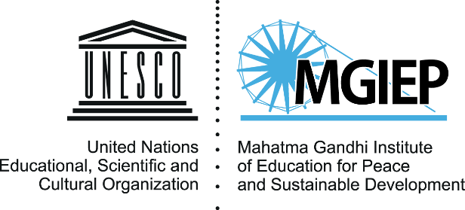

The South Asia launch of Rethinking Schooling for the 21st Century:
The State of Education for Peace, Sustainable Development and Global Citizenship in Asia

UNESCO House
San Martin Marg, New Delhi
Auditorium
2-4 pm
Thursday 30 October 2017

Background

Calls to gear up schools for the 21st century are ubiquitous today. Dominant international educational discourse hails the potential of ‘the youth dividend’ and digital technology for enhancing growth. Some Asian education systems are held up as models for an innovation-led utopian future. But across much of Asia, neither the reality of schooling nor the patterns of development with which it is associated give cause for blithe optimism.
Since its inception, UNESCO has championed a humanistic vision of education – a vision today encapsulated in SDG 4.7/ These ideals need to be strongly restated and defended in an era when educational debate worldwide has come to be framed by a narrowly economistic and instrumentalist agenda.
MGIEP’s Rethinking Schooling for the 21st Century: The State of Education for Peace, Sustainable Development and Global Citizenship in Asia was officially launched on 2 November 2017 at the 39th session of the UNESCO General Conference. Building on the content analysis of 172 official documents in 18 languages based on a common coding scheme and extensive literature review on Asian schooling, this report seeks to assess how far the aims and values encapsulated in SDG 4.7 have been incorporated into the educational policies and officially-mandated curricula of 22 Asian countries. By analyzing current policies, curricular frameworks, subject syllabi and textbooks, it aims to create a baseline against which further progress towards SDG 4.7 can be monitored. At the same time, it sets out to change the way we talk about and act upon SDG 4.7, and argues that a broader vision of education’s nature and social role is essential to our chances of achieving a peaceful and sustainable future for Asia and the world.
The South Asia launch of the Rethinking Schooling report will be held on 30 November 2017 in New Delhi as a side event of the Asia-Pacific Regional Workshop on the Global Action Programme (GAP) on Education for Sustainable Development (ESD) and Cities (28-30 November 2017). The key findings of this report will be presented by UNESCO MGIEP, followed by a panel discussion comprising of the Chair of the Core Drafting Group of the report and a member of the Review Committee of the report.

Tentative Agenda

13:00 – 14:00 Lunch

14:00 – 14:10 Welcome
- Anantha Kumar Duraiappah, Director, UNESCO MGIEP

14:10 – 14:35 Overview of the Project: Sustainable Development Goal (SDG) 4.7 and Key Regional Trends in Asia, Yoko Mochizuki, UNESCO MGIEP

14:35 – 14:45 Q & A

14:45 – 15:45 Panel discussion: The State of Education for Peace, Sustainable Development and Global Citizenship in South Asia and beyond

to be presided over by Prof Mrinal Miri, South Asian University

- Prof Krishna Kumar, Former Director, NCERT
- Prof Hari Vasudevan, University of Calcutta
- TBD

15:45 – 16:00 Closing

